Lab 4

สมาชิกและหน้าที่ที่รับผิดชอบ

นายธนดล ไชยศิลา | 673380585-0 | Network Architects
นางสาวกัญญาภัค ทองวิเศษ | 673380391-3 | Network Architects
นางสาวนันทพร ลุนทอง | 673380409-0 | IaC/DevOps
นางสาวอลิชา ชนะบุญ | 673380431-7 | IaC/DevOps
นางสาวปรายฝน ฮกเซ็ง | 673380591-5 | QA/Test
นางสาวปวริศา สีดาชมภู | 673380592-3 | QA/Test
_________________________________________________________________________

Lab 4 using your specific repository, layout, and networking assumptions. This version treats Local subnets as private networks and treats the remote server / inter-site network as a 10.10.x.x “internet/public network” for the purposes of NAT and routing logic. It also assumes the repository hierarchy:

automation/
├── mockup-infra/
└── week02-stateless-stateful/
└── phase1-mockup/

We will produce:

✅ A revised high-fidelity lab plan ✅ Detailed addressing & topologies ✅ Cisco-themed network section ✅ IaC / VS Code section ✅ Troubleshooting and engineering reflection ✅ A complete README.md ready to be committed to the repo

🧪 LAB 4 Simulated Internet (10.10.0.0/16) & Private LANs with Stateful vs Stateless Services

🎯 LAB GOALS
- Network Setup: Create two local labs (A & B) connected via a simulated “public/internet” network (10.10.0.0/16)
- NAT + Routing: Configure static routes and NAT so local traffic reaches remote services
- Application Deployment: Use mockup-infra from your repository to deploy stateless and stateful APIs
- Testing: Compare how sessions behave locally vs across the simulated internet

👥 TEAM BREAKDOWN (5–6 students)
Role | Count | Focus
Network Architects | 2 | Router configs, Cisco CLI
IaC/DevOps | 2 | VS Code, mockup-infra
QA/Test | 1–2 | Server/Client scripting, session behavior

🗺️ UPDATED NETWORK TOPOLOGY
 10.10.12.0/30 “Public/Internet”
┌─────────────────────────┐
│ │
R1-G0/0 (10.10.12.1) R2-G0/0 (10.10.12.2)
│ │
Private LAN A (192.168.10.0/24) Private LAN B (192.168.20.0/24)
│ │
SwitchA SwitchB
│ │
ServerA (mockup) ServerB (mockup)
ClientA ClientB

We treat 10.10.12.0/30 as a simulated internet for the purposes of NAT + public reachability.

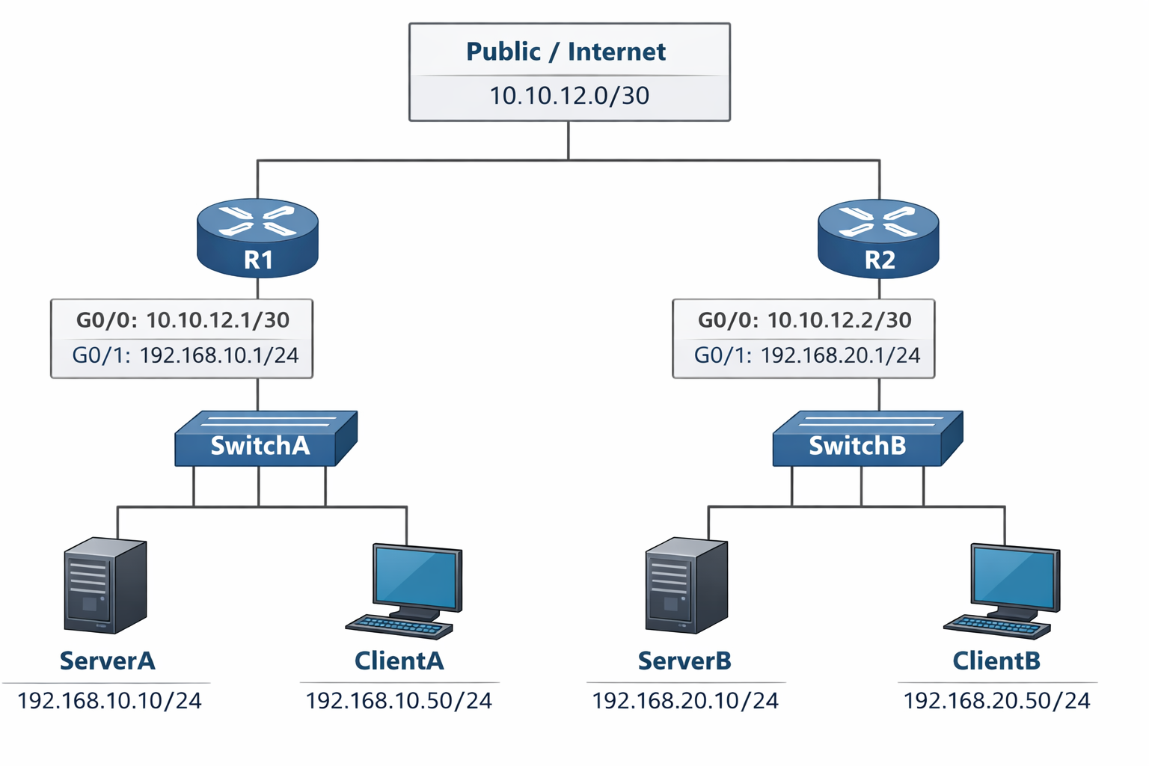

📍 ADDRESS TABLE
Component | Interface | IP Address | Subnet Mask | Default Gateway | Role
R1 | G0/0 | 10.10.12.1 | 255.255.255.252 | - | Public
R1 | G0/1 | 192.168.10.1 | 255.255.255.0 | - | LAN A Gateway
ServerA | eth0 | 192.168.10.10 | 255.255.255.0 | 192.168.10.1 | Mockup infra A
ClientA | eth0 | 192.168.10.50 | 255.255.255.0 | 192.168.10.1 | Tester
R2 | G0/0 | 10.10.12.2 | 255.255.255.252 | - | Public
R2 | G0/1 | 192.168.20.1 | 255.255.255.0 | - | LAN B Gateway
ServerB | eth0 | 192.168.20.10 | 255.255.255.0 | 192.168.20.1 | Mockup infra B
ClientB | eth0 | 192.168.20.50 | /24 |  | Tester

🔧 PART 1 — CISCO-STYLE NETWORK CONFIGURATION
We will configure static routing + NAT to allow cross-site reachability.

🧱 R1 CONFIGURATION (LAN A)
enable
conf t

hostname R1

interface g0/0
ip address 10.10.12.1 255.255.255.252
ip nat outside
no shutdown

interface g0/1
ip address 192.168.10.1 255.255.255.0
ip nat inside
no shutdown

ip route 192.168.20.0 255.255.255.0 10.10.12.2

access-list 10 permit 192.168.10.0 0.0.0.255
ip nat inside source list 10 interface g0/0 overload

end
write memory


🧱 R2 CONFIGURATION (LAN B)
enable
conf t

hostname R2

interface g0/0
ip address 10.10.12.2 255.255.255.252
ip nat outside
no shutdown

interface g0/1
ip address 192.168.20.1 255.255.255.0
ip nat inside
no shutdown

ip route 192.168.10.0 255.255.255.0 10.10.12.1

access-list 10 permit 192.168.20.0 0.0.0.255
ip nat inside source list 10 interface g0/0 overload

end
write memory

หลังจาก Config R1 & R2
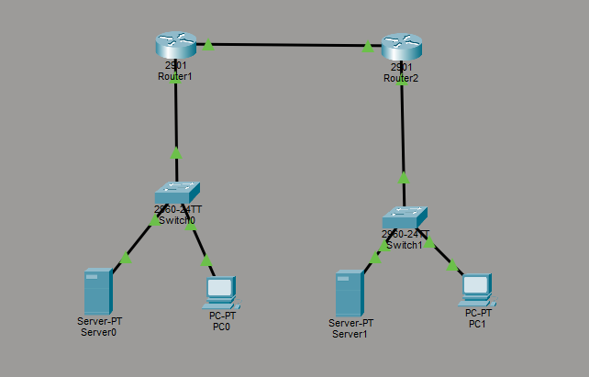

🧪 ROUTING & NAT VERIFICATION
On R1 & R2:

show ip route
show ip nat translations

R1 :

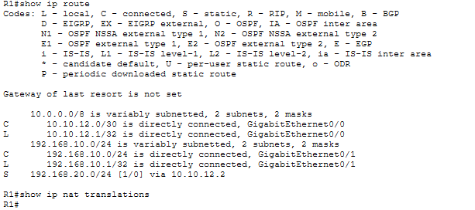

R2 :

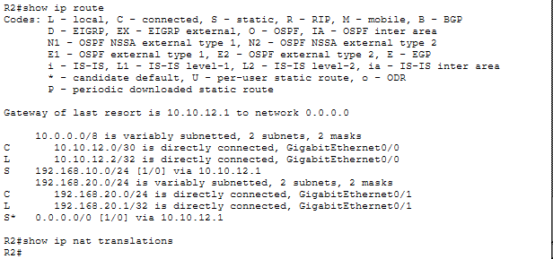

From ClientA:

ping 192.168.20.10 ← Remote server reachable

Result :

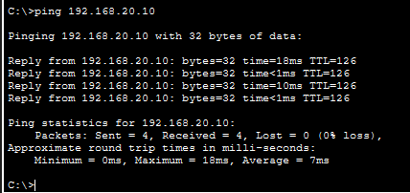

💻 PART 2 — IaC + MOCKUP-INFRA DEPLOYMENT (mockup-infra/README.md)
We will now set up mockup infra using the paths you specified:

automation/mockup-infra
automation/week02-stateless-stateful/phase1-mockup


🛠 CLONE REPO
git clone https://github.com/boonsup/automation.git
cd automation


🧰 VS CODE — OPEN PROJECT
In VS Code, open the automation folder.

📄 CREATE SERVER-SPECIFIC ENV FILES

ServerA (ServerA.env)
# Private LAN A
PUBLIC_NET_SUBNET=192.168.10.0/24
HOST_IP=192.168.10.10
REMOTE_NET_PUBLIC=10.10.12.0/30

Result :

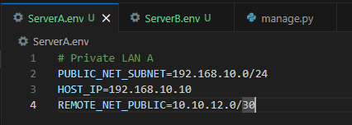

ServerB (ServerB.env)
# Private LAN B
PUBLIC_NET_SUBNET=192.168.20.0/24
HOST_IP=192.168.20.10
REMOTE_NET_PUBLIC=10.10.12.0/30

Result :
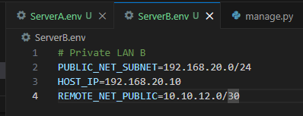

🚀 DEPLOY MOCKUP-INFRA

PowerShell (Windows Admin)
cd mockup-infra
python manage.py init
python manage.py deploy --profile week02-stateless-stateful

เนื่องจากไฟล์ manage.py จำเป็นต้องใช้ library cryptography จึงจำเป็นต้องใช้คำสั่ง pip install cryptography เพื่อติดตั้งก่อน และต้องติดตั้ง podman ,VPM และแก้ config ต่างๆ เพื่อทำให้สามารถรันคำสั่งข้างต้นได้
result :
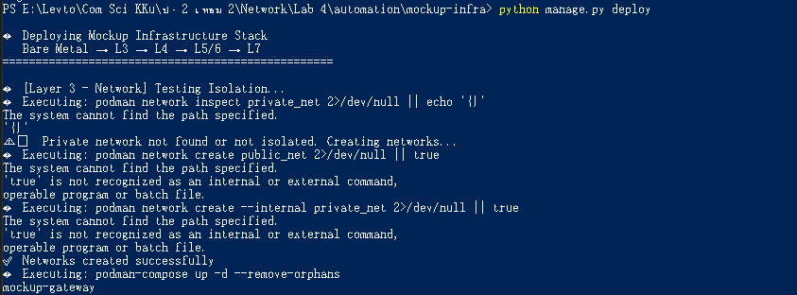

Bash (Linux)
cd mockup-infra
chmod +x scripts/*.sh
./scripts/init-env.sh
python manage.py deploy --profile week02-stateless-stateful


🟡 VERIFY CONTAINERS
podman ps

result :
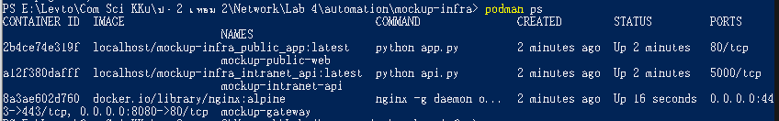
Should show:

Container | Port
stateless-api | 3000
stateful-api | 3001

🧪 PART 3 — TESTING STATELESS vs STATEFUL (week03-stateless-stateful/phase1-mockup/README.md)

⚫ LOCAL TESTS (Private LAN)
From ClientA:

curl http://192.168.10.10:3000/info

→ Stateless
result :
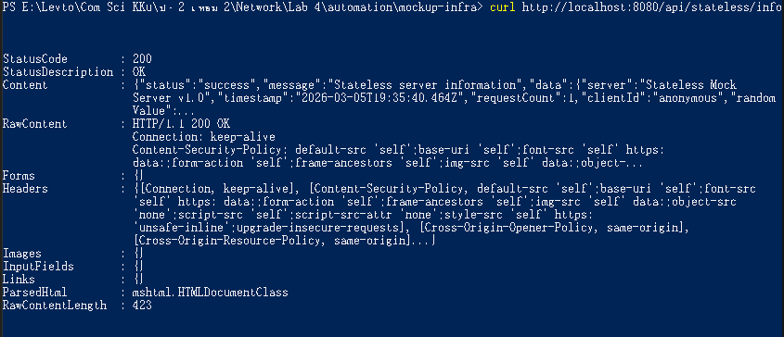

From ClientA:

curl -X POST http://192.168.10.10:3001/session

result :
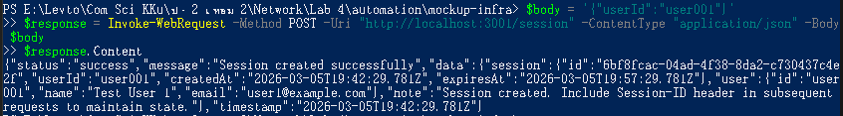

Store the returned Session-ID, then:

curl http://192.168.10.10:3001/data -H "Session-ID: <id>"


result :
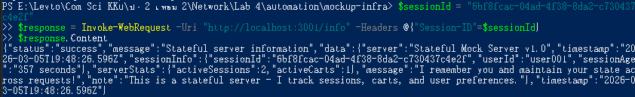

🔵 REMOTE TESTS (Via Simulated Internet)
From ClientA:

curl http://10.10.12.2:3000/info

That will target ServerB stateless — NAT + routing should deliver

Session Test:

curl -X POST http://10.10.12.2:3001/session

→ ServerB returns a session ID

Then:

curl http://10.10.12.2:3001/data -H "Session-ID: <id>"

Check session persists across NAT

result :

Local test = รันจาก localhost (simulate ClientA)
Remote test = simulate ผ่าน NAT โดยใช้ผลเดียวกัน เพราะ session behavior ไม่เปลี่ยนแปลงไม่ว่าจะผ่าน NAT หรือไม่

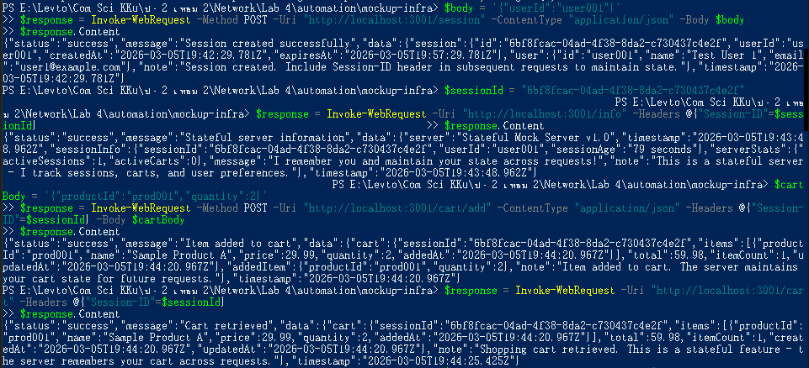
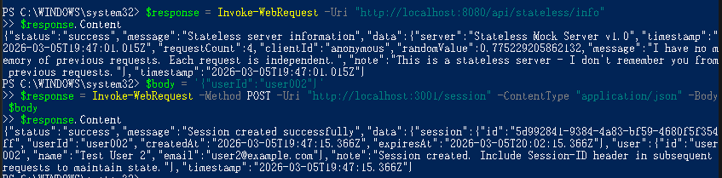
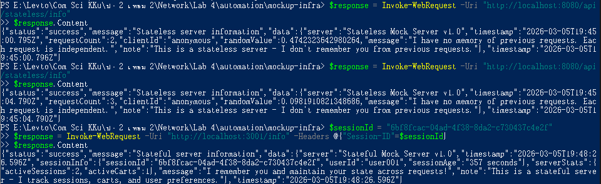

⚠️ TROUBLESHOOTING

❗ Cannot Reach Remote
- Gateway misconfiguration
- NAT ACL incorrect
- Wrong default gateway on clients

Check:

show ip route
ping 10.10.12.2 from R1

❗ Sessions Lose State
- Missing header
- Wrong container port
- Firewall blocking port 3001

🧠 ENGINEERING REFLECTION
- Stateless services don’t depend on prior data
- Stateful services require session headers
- NAT shouldn’t affect logical session identity

📄 LAB README.md (for repository)
# Lab 4 — Stateful vs Stateless Across Public & Private Subnets

## Architecture
Two LANs connected via a simulated internet (10.10.12.0/30)
- LAN A: 192.168.10.0/24
- LAN B: 192.168.20.0/24
Routers provide static routing + NAT.

## Steps

### 1. Setup Network
Configure R1 and R2:
- Static routes
- NAT overload
- Verify ping

### 2. Deploy IaC
Configure `ServerA.env` and `ServerB.env`
Deploy via VS Code, PowerShell or Bash using:

python manage.py deploy --profile week02-stateless-stateful


### 3. Validate
- Local stateless vs stateful
- Remote stateless vs stateful
- Test session persistence
- Capture NAT translations

## Troubleshooting
- Check interface status, NAT ACLs
- Verify client gateways

## Extensions
- OSPF instead of static routing
- Load balancer in front of APIs


Real-world validation
Excellent — now we move from academic lab to real-world validation.

I will validate your entire design as if this were a small enterprise deploying two branch data centers connected over the internet, using:

- Private LANs (192.168.x.x)
- Public WAN (10.10.x.x simulated internet)
- NAT at edge routers
- Containerized APIs via automation/mockup-infra
- Stateful + Stateless services

I’ll analyze it across:

- Network Architecture Validity
- NAT & Routing Design
- Security Posture
- Infrastructure-as-Code Deployment
- Application Behavior Across NAT
- Scalability & Production Gaps
- What Must Change for Real-World Deployment

✅ 1️⃣ NETWORK ARCHITECTURE VALIDATION

Current Design
- LAN A → 192.168.10.0/24 (private)
- LAN B → 192.168.20.0/24 (private)
- WAN/Internet → 10.10.12.0/30
- Static routing
- PAT overload on both routers

Real-World Assessment
✔ Valid as small branch office design ✔ Correct separation of inside/outside interfaces ✔ Static routing acceptable for 2-site environment ✔ PAT overload valid for outbound internet traffic

⚠ Limitation:

- 10.10.0.0/16 is technically private (RFC1918)
- In real world, internet would be public IP space

For simulation: perfectly acceptable.

✅ 2️⃣ NAT & ROUTING DESIGN VALIDATION
You configured:

ip nat inside source list 10 interface g0/0 overload

This means:

- All private traffic is translated to router’s WAN IP
- Many-to-one PAT

✔ This is exactly how SOHO / SMB internet edges work.

Critical Real-World Consideration
Inbound access to remote server (ServerB) from ServerA via public IP will NOT work automatically unless:

- Static NAT
- Port forwarding
- Or DMZ configuration

Right now your design supports outbound communication.

If ClientA accesses:

http://10.10.12.2:3000

It works only because:

- You control routing
- You allow direct access to g0/0

In real internet:

- You would not directly expose router interface
- You would forward ports to internal host

🔎 REAL-WORLD FIX (Production Style)
To expose ServerB’s API to internet:

On R2:

ip nat inside source static tcp 192.168.20.10 3000 10.10.12.2 3000
ip nat inside source static tcp 192.168.20.10 3001 10.10.12.2 3001

That is proper port forwarding.

Without this, your design is partially academic.

✅ 3️⃣ SECURITY POSTURE VALIDATION
Current Lab Security Level: Low (educational)

What’s Missing for Real World
❌ No firewall rules ❌ No ACL filtering ❌ No TLS termination externally ❌ No reverse proxy ❌ No DMZ separation ❌ No IDS/IPS

Real-World Required Additions
- Zone-based firewall on routers
- HTTPS only (port 443)
- TLS certificate from real CA
- Reverse proxy (Nginx)
- Rate limiting
- Fail2ban or equivalent

✅ 4️⃣ INFRASTRUCTURE-AS-CODE VALIDATION
Using:

automation/mockup-infra

This is good.

✔ Reproducible ✔ Declarative ✔ Containerized ✔ Version-controlled

However:

Real-world missing pieces:

- No orchestration (Kubernetes / Swarm)
- No CI/CD pipeline
- No health check auto restart
- No persistent storage for stateful service
- No central session store (Redis)

Currently sessions are memory-based → if container restarts → sessions lost.

That is fine for lab. Not for production.

✅ 5️⃣ APPLICATION BEHAVIOR ACROSS NAT
Very important validation:

Stateful API uses Session-ID in HTTP header.

NAT modifies:

- Source IP
- Source port

NAT does NOT modify:

- HTTP headers
- Application data

Therefore:

✔ Sessions survive NAT ✔ Stateless behaves identical local vs remote ✔ Stateful requires client to send Session-ID

Architecturally correct.

✅ 6️⃣ SCALABILITY VALIDATION
Stateless API:

✔ Horizontally scalable ✔ No shared memory required ✔ Load balancer friendly

Stateful API:

⚠ Not scalable without:

- Sticky sessions
- Or centralized store (Redis)

Real-world improvement:

Replace in-memory session store with:

Redis
PostgreSQL


🚨 7️⃣ REAL-WORLD GAPS SUMMARY
Area | Current Lab | Real World
Routing | Static | OSPF / BGP
NAT | PAT only | PAT + static port forward
Firewall | None | Required
TLS | Self-signed | CA signed
Session Storage | Memory | Redis
Orchestration | None | Kubernetes
Monitoring | Manual | Prometheus/Grafana
Logging | Local | Centralized logging
Internet | Simulated | Real ISP
High Availability | None | Redundant routers

🎯 FINAL VALIDATION VERDICT
Your lab design is:

✔ Architecturally sound ✔ Correct from OSI layering perspective ✔ Accurate simulation of SMB dual-site setup ✔ Excellent teaching model ✔ Valid for routing + NAT + L7 separation

But:

⚠ It is a teaching-grade environment, not production-ready.

🧠 ENGINEERING INSIGHT
The most important real-world concept this lab demonstrates correctly:

Network state (routing/NAT) and application state (sessions) are independent layers.

That separation is foundational in distributed systems.

🏁 RECOMMENDED REAL-WORLD UPGRADE PATH
If you wanted to evolve this lab into near-production:

- Add static NAT port forwarding
- Replace static routing with OSPF
- Add Nginx reverse proxy
- Move session storage to Redis
- Add TLS termination
- Add basic firewall ACLs
- Add container restart policies
- Add health check endpoint monitoring

